1. **Problem definition and description**

The main target of the project is to i) find the population proportion of call types of taxis and ii) to provide its error range with a 95% level of confidence. The characteristics of the population could be figured out through these processes using the given sample.

1. **Core code**

# define a calculator

class prop_calculator():

def __init__(self, prop_num, sample_num):

# a number of the counted call types

self._prop = prop_num

# a total number of trajected samples

self._samples = sample_num

# calculate sample ratio

def sample_prop(self):

return round(self._prop / self._samples, 5)

# calculate sample standard deviation

def sigma_calc(self, p_hat = None):

if p_hat == None:

p_hat = self.sample_prop()

return round(np.sqrt((p_hat * (1 - p_hat)) / self._samples), 5)

# calculate confidence interval

def confidence_interval(self, p_hat = None, sigma_hat = None):

if p_hat == None:

p_hat = self.sample_prop()

sigma_hat = self.sigma_calc(p_hat)

return round(p_hat - 1.96 * sigma_hat, 5), round(p_hat + 1.96 * sigma_hat, 5)

# draw pie charts

import matplotlib.pyplot as plt

ratio = [a_ratio, b_ratio, c_ratio]

labels = ["Central Based", "Stand Based", "Random Street"]

plt.pie(ratio, labels = labels, autopct='%.3f%%')

plt.title("Porto Taxi Demand Population Proportion")

plt.show()

1. **Results and plots**

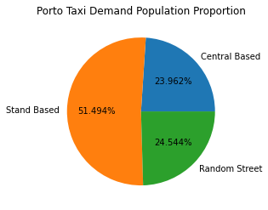

**Figure 1 Pie Chart of the Porto Taxi Demand**

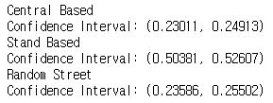

**Figure 2 Confidence Interval of the Proportion (with a 95% level of confidence)**

1. **Discussion**

Please submit the project paper in a wooden box hanging on the wall of the office in Room 3205.

1. **Refernces**

References in the text should follow the standard format (Brown, 1997). As Brown (1997) suggested, they should be in the format shown immediately below. References are in 11 pt of Times Roman font. Journal titles should be in full. Journal and book titles should be italicized. Multiple authors should all be listed.